**EXPERIMENT-3**

**AIM**

To design and deploy a simple **Property Buying & Rental software application** for Chennai city using a Cloud Service Provider (CSP) and demonstrate the concept of **Software as a Service (SaaS)**.

**PROCEDURE**

Cloud SaaS App â€“ Property Buying & Rental System (Chennai) in Zoho Creator

Step 1: Create the App

1. Login to https://creator.zoho.com/

2. Click "Create New Application â†’ From Scratch"

3. Name the app: "Chennai Property Portal"

Step 2: Create Forms (Database Tables)

(a) Properties Form

- Property ID (Auto Number â†’ Prefix: P, Start: 1001)

- Owner Name (Single Line)

- Property Type (Dropdown â†’ Apartment, Villa, Plot, Commercial)

- Location (Dropdown â†’ Anna Nagar, T. Nagar, Velachery, OMR, Tambaram, etc.)

- Address (Multi Line)

- Price (Currency)

- For (Dropdown â†’ Sale, Rent)

- Status (Dropdown â†’ Available, Sold, Rented)

(b) Applications Form (Buyer/Tenant Requests)

- Application ID (Auto Number â†’ Prefix: A, Start: 2001)

- Applicant Name (Single Line)

- Email (Email)

- Phone (Phone)

- Property Applied For (Lookup â†’ Link to Properties Form)

- Application Type (Dropdown â†’ Buy, Rent)

- Application Status (Dropdown â†’ Pending, Approved, Rejected)

Step 3: Add Business Logic (Deluge Script)

Go to Applications Form â†’ Workflows â†’ On Success.

Paste this script:

propertyRec = Properties[ID == input.Property_Applied_For];

if(input.Application_Status == "Approved")

{

if(input.Application_Type == "Buy")

{

propertyRec.Status = "Sold";

}

else if(input.Application_Type == "Rent")

{

propertyRec.Status = "Rented";

}

}

Step 4: Create Reports (UI Views)

- Available Properties â†’ Filter where Status = "Available"

- Sold/Rented Properties â†’ For Admin review

- My Applications â†’ Shows requests made by the logged-in user

- Admin Dashboard â†’ All properties + applications

Step 5: Manage Users (SaaS Feature)

1. Go to Settings â†’ Users & Permissions

2. Create roles:

- Admin â†’ Add properties, approve/reject applications

- Buyer/Tenant â†’ View available properties, apply

- Owner â†’ List their properties

3. Invite users via email & assign them roles

Step 6: Publish the App (SaaS Demo)

1. Go to Settings â†’ Publish â†’ Enable Access

2. Share the app link with buyers/tenants/owners

3. Everyone can use the same app â†’ SaaS model

**OUTPUT**

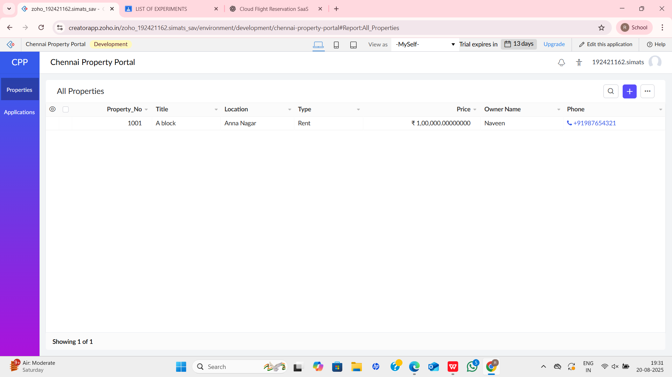

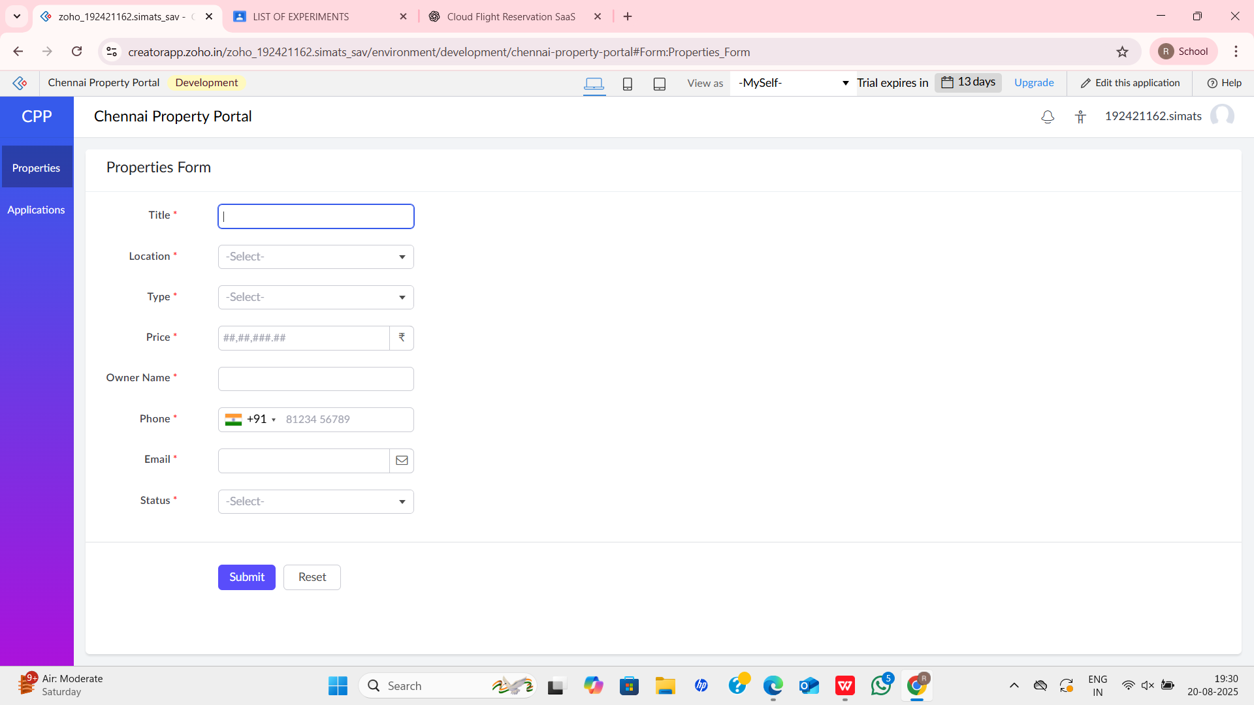

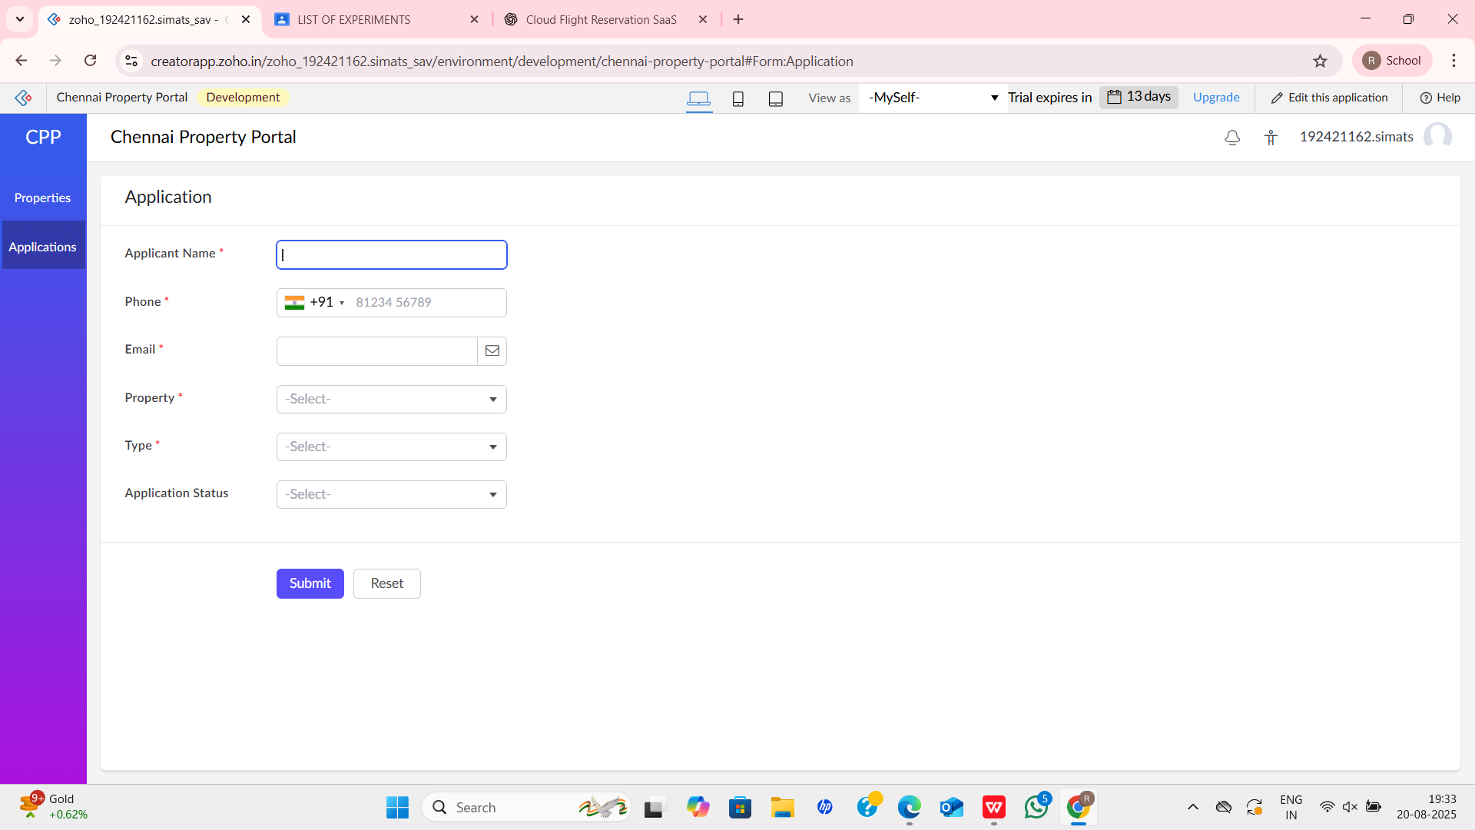

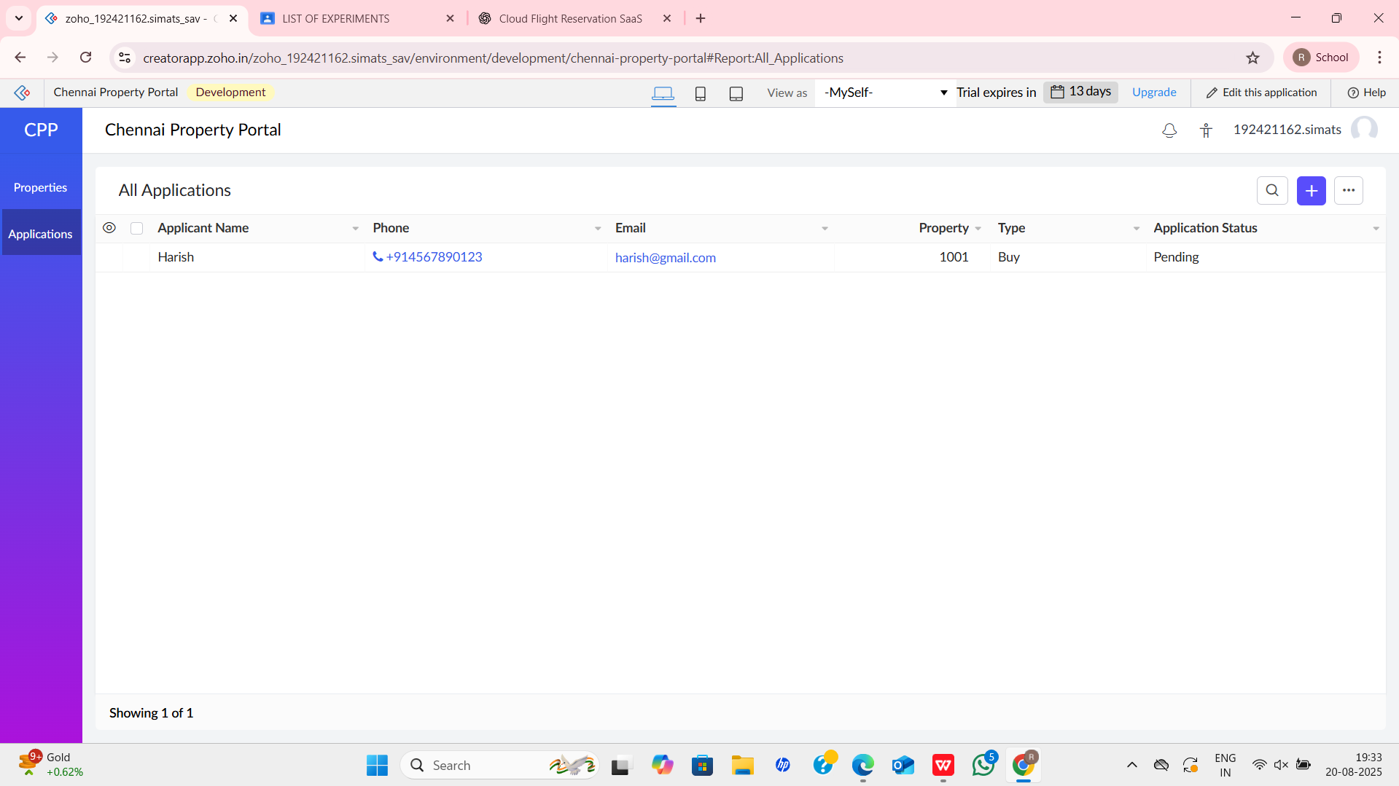

**RESULT**

A **Property Buying & Rental application for Chennai city** was successfully developed and deployed on the cloud. The system enables users to **list and search properties online** without installing software, thus demonstrating the concept of **Software as a Service (SaaS)**.

brary was successfully developed and deployed on the cloud. The application can be accessed by students and librarians via a web browser without installation, thus demonstrating the concept of Software as a Service (SaaS).